MEMBERSHIP FORM FORM

1 Banksia Crescent, Parafield Gardens, SA-5107

Adelaide-BangladeshiCultural Club(ABACC)

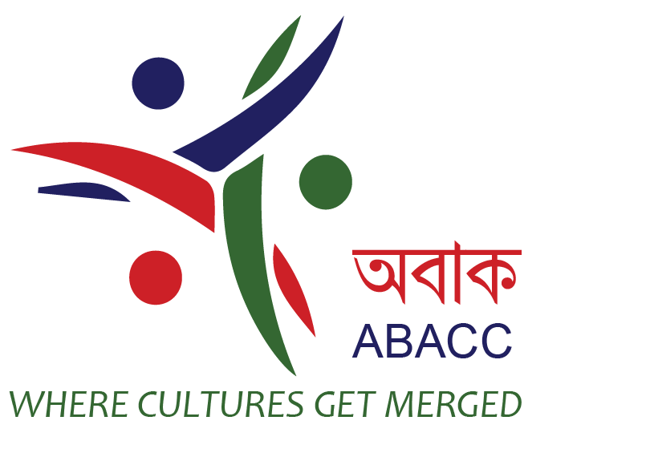
- music & dance
- art & culture
- language

All prospective members of ABACC are required to complete this registration form. Membership runs from 01 July 2020 -30 June 2021

NEW MEMBERSHIP RENEWAL

SECTION 1: MEMBER CONTACT INFORMATION

Title | MrMrsMissMs
Name
Spouse Name
Child 1 | Name: DoB:
Child 2 | Name: DoB:
Child 3 | Name: DoB:
Address |  | Home Ph
 | Suburb | Mobile-1
Suburb: |  | Mobile-2
P/Code |  | Email-1
Referred By |  | Email-2

SECTION 2: MEMBERSHIP TYPE AND PAYMENT DETAILS

Membership Type | Description | Membership Fees (Annual) | Please Check
Full | Full Membership(Family) | AUS$30.00
Student/Retired | Full time students and Retired Members(Family) | AUS$15.00
Payment method | Cash OnlineBank Transfer*

Membership Rules

I have read, understood, and accepted the rules for membership.
MEMBERSHIP RULES
1. Membership is available to anyone 16 years of age or older.
2. You promise NOT to use to conduct any fraudulent or business activity.
3. Keep the harmony & ethics of ABACC
4. Membership will be automatically Cancel if membership fees NOT PAID two consecutive years.

Signature-1: _______________ Date: / / Signature-2: ________________ Date:/ /

*To pay membership fees/any donation by online bank transfer(pls mention your name as reference):

A/C Name: Adelaide Bangladeshi Cultural Club BSB:065 124 A/C Number:10339700

Change/update any information of yourself (ie. address, contact details) please visit our website.

